Hello! My name is Celine and I was an exchange student from Northfield, Minnesota. I have spent this past semester at the University of Otago studying Psychology and Education. I heard about Quarantine Island from the Social Impact Studio at the University (thank you Sye-En and Poppy!) I first met Jon this fall when he gave me a tour of the island. We spent a sunny day walking around the historic buildings and grassy paddocks while Jon shared the history of the island with me. We also started brainstorming ideas for projects I could help out with around the island. I attended a Welcome Day which is a great way to meet all of the volunteers and people who help maintain the island. I returned in mid-July to spend two weeks living and volunteering on the island.

Jon came to pick me up in his boat in Port Chalmers, where he had gotten soaked from the waves caused by the northbound wind. Luckily he had some trash bags which we used to waterproof my stuff before setting off through the waves back to the island. When we arrived, I spent some time unpacking and moving in. I loved seeing the golden hour light stream into my bedroom window. After settling into my room at the lodge, I spent some time exploring around the island, enjoying the sunshine despite the strong wind. Jon explained how multiple times this winter he has been unable to make the crossing to the port due to the winds, so he has had to make sure to be well-stocked on food to avoid running out.

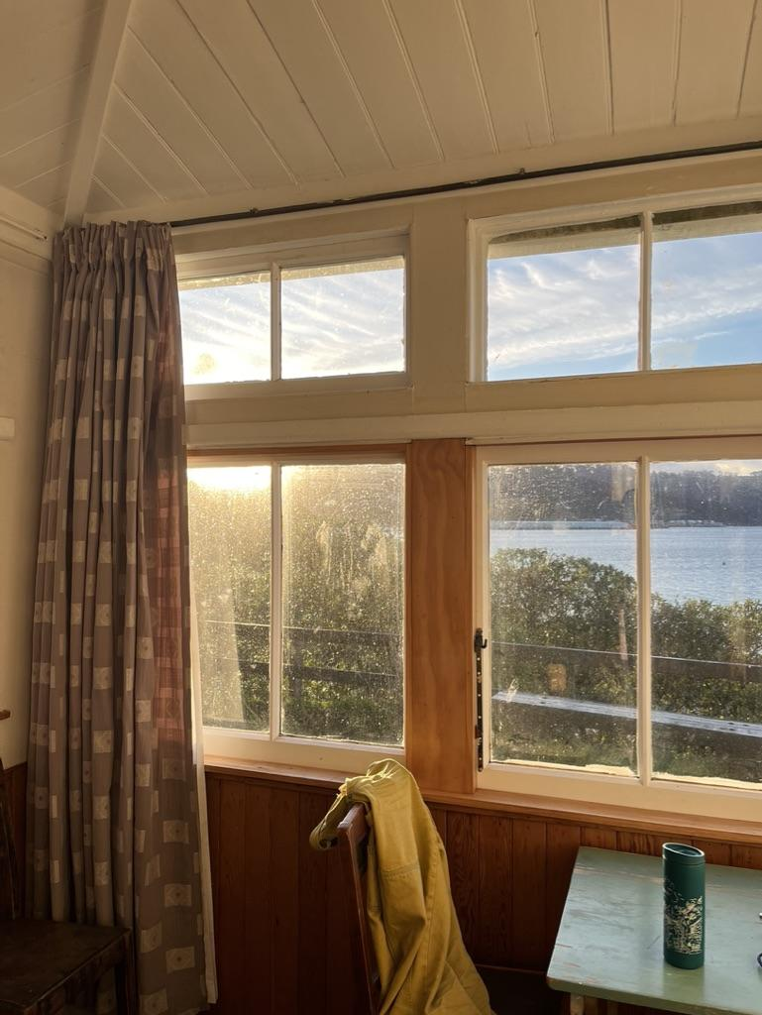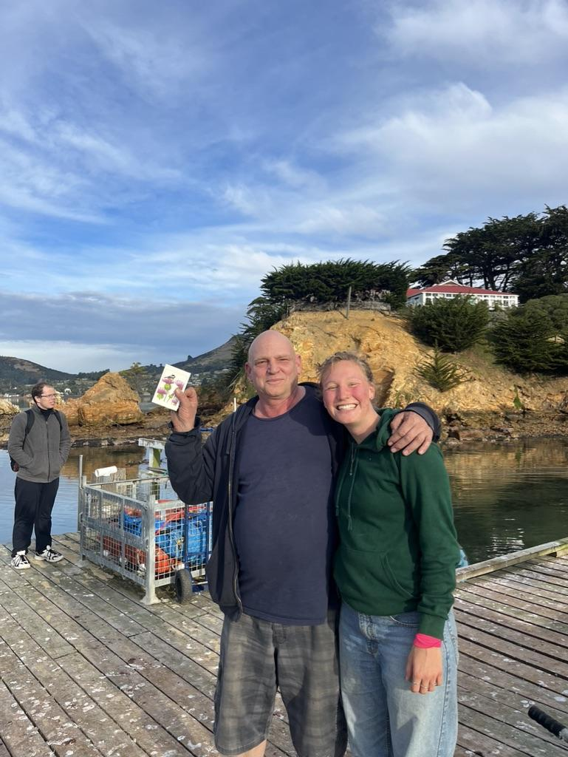

I decided to focus on inside tasks due to rain on my second day. I spent time cleaning the window sills and sweeping in the lodge and married quarters. After a morning of cleaning, I was happy to curl up with a book and a cup of tea in the afternoon.

On my third day, Jon and I worked together to clean all of the windows in the lodge. And wow, now the ocean view is crystal clear!! I have been amazed by the stunning views all around the island and have taken so many photos and videos. I also spent some time in the greenhouse weeding and emptying bins full of water from the rain. Jon gave me a radio so that the lodge was less quiet. I have enjoyed listening to the news and music from Dunedin, as I have been fervently knitting my first-ever sweater.

I spent my fourth-day trimming grass from around native plants that have been planted on the island. Every third Saturday of the month, “Welcome Days,” groups of volunteers gather on Quarantine Island to plant native plants around the island. Quarantine Island is working to remove pest plants, while also increasing the number of native plants. Another part of Welcome Days is to collect small native plants and transfer them to the greenhouse in order to protect them while they grow before they are planted on the island again. It was very cool to see just how many native plants are growing here and it really shows all of the hard work of the volunteers who support the replanting projects on the island.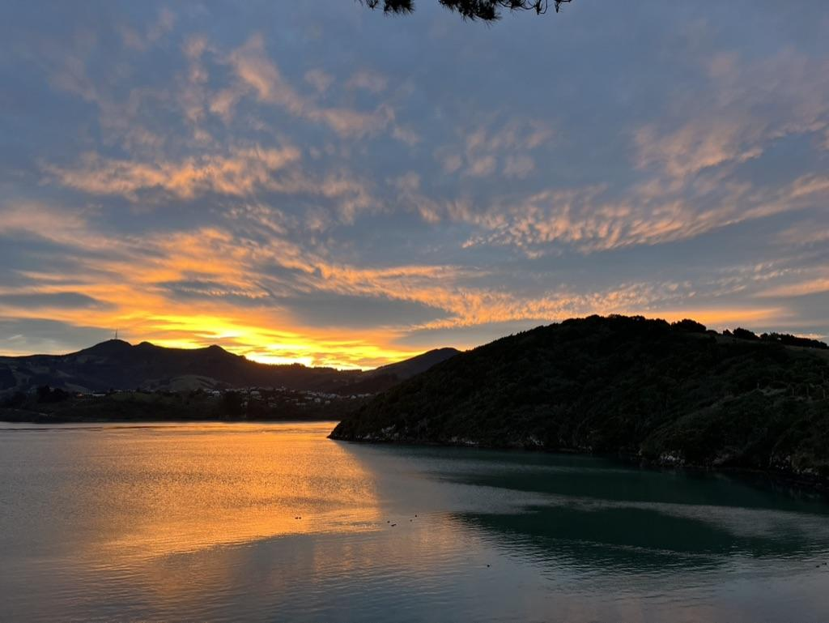

On my fifth day, Jon and I set about fixing.the electrical fence together to stop the sheep from getting through. However by sunset that same day Katie, the black sheep, had miraculously already figured out how to cross the fence once again. I also spent some time weeding one of the garden beds and was excited to find many potatoes! That evening Jon very kindly made us a delicious dinner of vegetable barley soup and homemade olive bread. It has been really nice to spend time with Jon as we share a meal or a task, while also having plenty of time to explore the island by myself and relax. I have been knitting and reading up a storm and have listened to many downloaded podcasts while enjoying the views all around the island on the multitude of benches scattered about.

As my time continued on the island, the weather became nicer and the sun was out more frequently. I got out kayaking multiple times around the island and enjoyed the beautiful weather and calm water. I felt so free running on the grassy hills, basking in the sunlight on the shore, and reading my book as I watched the sunset and moon appear. Jon and I shared more dinners and breakfasts talking about American politics. I also did a big project with Ross, a volunteer, going through most of the plants in the greenhouse deciding what could be planted, what was dead, and what needed more time. I am so grateful for the opportunity to be able to spend almost two weeks on this wonderful island, where I was able to engage in such a wide range of activities. I am glad I brought my knitting, my journal, and many books for all of the relaxing and lovely downtime. I will take the memories, knowledge, and experiences I gained from my time on Quarantine Island with me as I start my bittersweet journey back to the U.S.

