Welcome to the Quarantine Island Treasure Hunt

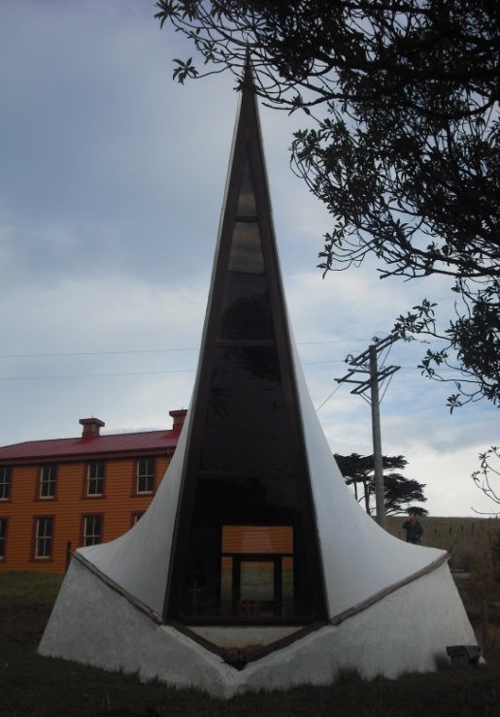
The treasure hunt will take you around the Island. Collect the clues at each stop, while learning about the history of each place!
The first clue:
- It is triangular in shape, with a view of the harbour down to Aramoana through a tall narrow window.
- Bob Oakley was the architect of the little church -a chapel.
- In the late 1960s the chapel was gradually built, the walls from rammed earth. Can you imagine what might have been hard about building it?

Clue 2:
- Head to the Married Quarters.
- It is the only quarantine building that remains standing on the island. It is famous in Otago and nationally.
- The restoration of this Historic Place has been a major undertaking. Look at this photo and others to see how it has changed over time.
- Originally the single women’s quarters and dining hall stood next to the Married Quarters and the single men were housed on Goat Island across the channel.
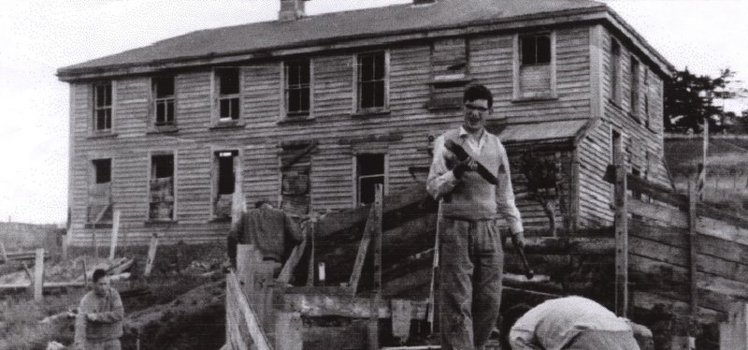

Clue 3: Swing

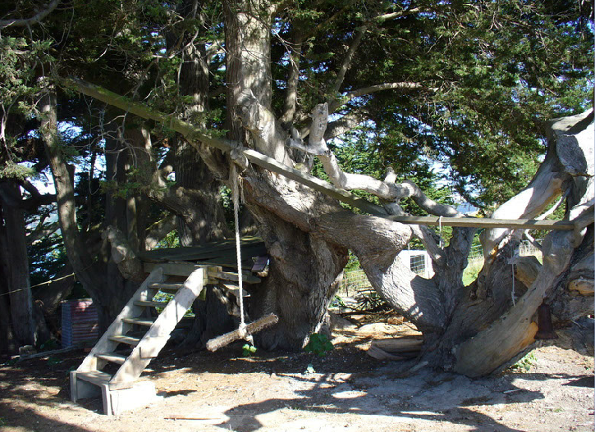
- Head to the rope swing, What has changed since the photo?
- Find the next clue!

Clue 4:
You walked under this welcoming archway when you arrived. It was carved by a member of the Island Community, Pav Pawlowicz, in 2008. There is so much interesting detail. How much did you notice? For example, what 3 types of birds are there? What is carved on the left of the side shown in the photo?
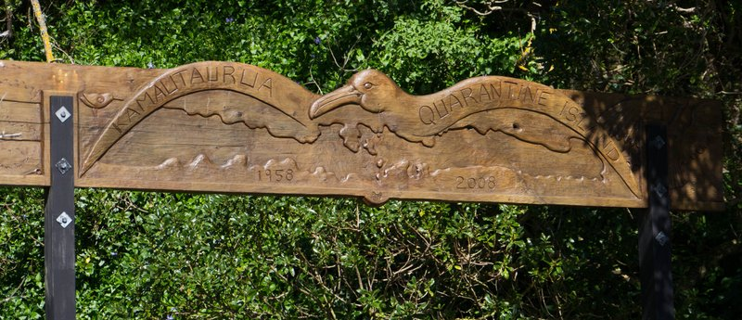
Who watches from the other side, challenging us to protect his domain- the sea?

Clue 5

- At the top of a little slope, looking out towards Portobello, stands a brick double chimney, all that is left from the second hospital building. Go there.
- The hospital was built in 1873, with two wards, as the first hospital had been too small and was inadequate
- There are pegs outlining the hospital. See how big it was!
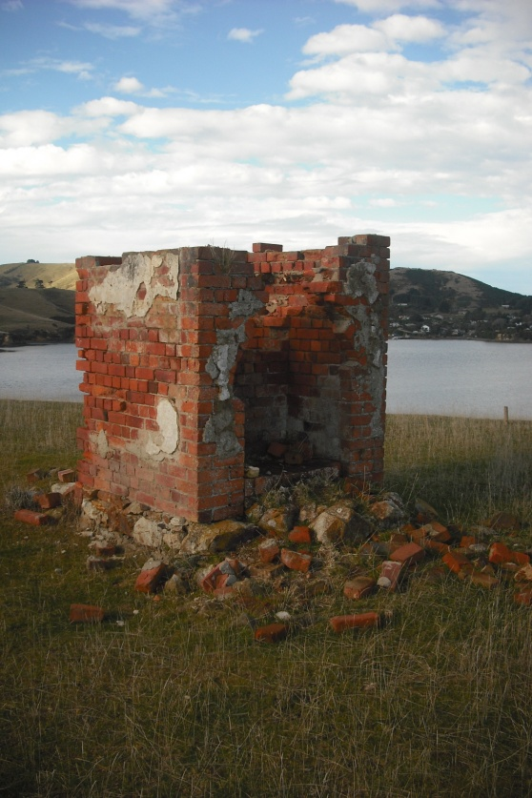

:

Clue 6:
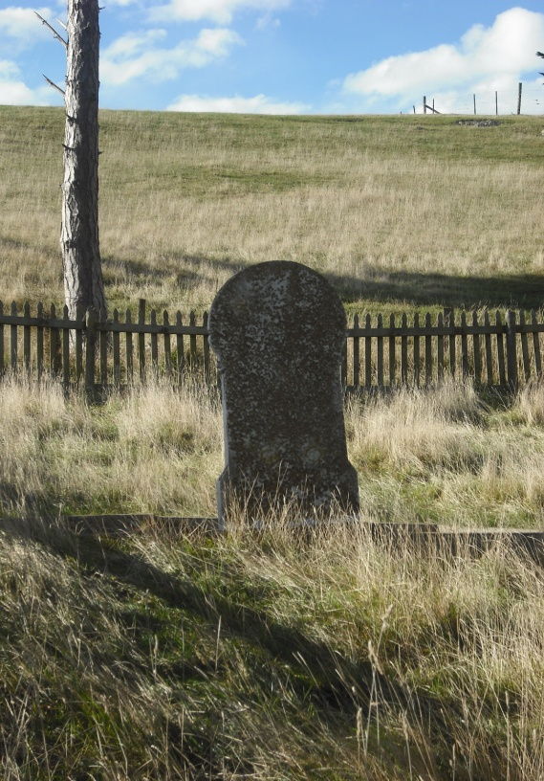
- Head northwest to the Cemetery.
- The Cemetery contains about 70 unmarked graves of the early immigrants
- The headstone of the 1860’s “Keepers of Quarantine,” John Dougall and his family is also there. Can you make out the inscription?
- There is also a memorial to the Rev. Dave Wilson, the Community’s first resident Keeper, who lived and worked on the Island for 10 years.

Clue 7:
Head to the old Keepers Cottage- now 'St Martin Lodge', added to 90 years ago with stained glass windows and porches.
You deserve a reward for your hunt! Ring the ships bell to celebrate your success.

